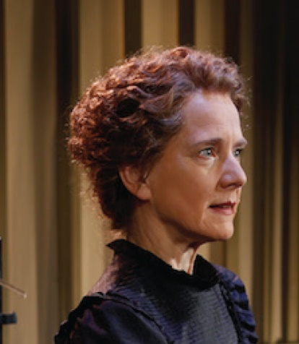
Manya

All are welcome

Saturday, October 19, 2019
Laney College
Odell Johnson Performing Arts Theater
900 Fallon Street
Oakland, CA 94607

Time
2:30PM

Reservation and Payment Required
By one of the following options:
1. Brown paper tickets: click Manya
2. Email office@calacs.org
3. Phone 510-351-9922
For either option #2 or #3, send a check for the desired number of tickets (indicating student or regular) made payable to: CA Section, ACS, 2950 Merced St., #225, San Leandro, CA 94577, postmarked no later than October 4, 2019. Individuals needing special assistance (ADA), allergies, etc. should notify CA Section ACS.

Cost
$15 ($8 for students and the unemployed)
with support of

California Section
American Chemical Society

This is a living history presentation of one of our most famous chemists, Marie Curie, and allows us to celebrate the International Year of the Periodic Table (IYPT) in grand style. The story starts with childhood memories that include Marie's dawning interest in science and her determination to conquer obstacles to obtaining an education in politically oppressed Poland - where women were not allowed to obtain schooling after gymnasium (high school). It then traces her migration to the Sorbonne, her unconventional romance with Pierre Curie, the birth of their first daughter, and the basis of Marie's scientific investigations that led to the discovery of two new elements (polonium and radium), an understanding of radioactivity, and the use of radium therapy against cancer.
Susan Marie Frontczak

About Susan Marie Frontczak

In dramatizing the life of Marie Curie, Susan Marie pays homage to their shared Polish heritage. Marie Curie's perseverance in purifying a tenth of a gram of radium from a ton of pitchblende, in part, inspired Susan Marie to earn an Engineering degree from Swarthmore College and a Masters in Software Engineering from the Wang Institute of Graduate Studies. She worked for fourteen years at Hewlett-Packard Company before pursuing full time writing and performing. It is her aim to reveal the human behind the scientist, while placing Marie Curie's life and accomplishments in a memorable historical context.

About your Role
As attendees, you will be invited to participate in a networking event immediately following the performance. Students have a chance to win a prizes, so don't miss out!

Directions
Go to Laney College’s website to chart the most suitable route
Parking: Free on Saturday on the Laney College campus
Public Transportation: Lake Merritt BART station is within walking distance to Laney College.
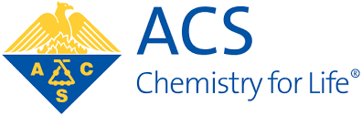
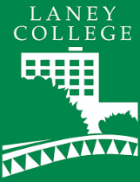
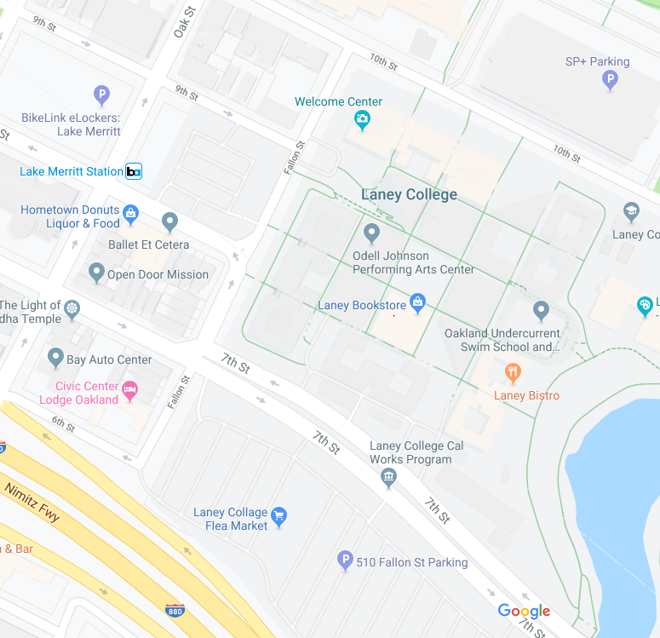

In Partnership With
The World’s Largest Scientific Society

