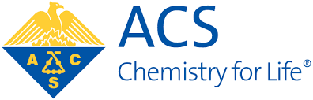

California Section

Chemistry and AI: exploring new research areas within industry and academia

Thursday – April 25, 2019 – 6:00 to 9:00 PM
“Biome” – Digital Innovation Labs by Novartis
17th Floor
44 Montgomery St., San Francisco, CA 94104

6:00 PM | Networking and Refreshments
6:30 PM | Welcome, Panel, and Q&A
7:45 PM  7:50 PM | Concluding Remarks  Networking and Refreshments

Discussion on Bay Area research…Come join us to learn more about the future of chemistry and artificial intelligence. Our panelists will discuss current research on using A.I. to help develop the future of medicine, small molecule discovery, quantum computing, and opportunities for collaboration. First event out of a series of events on this topic!

RSVP here!

Our Distinguished Panelists:

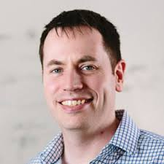 | 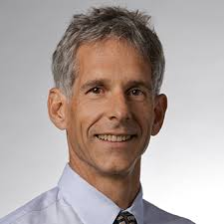 | 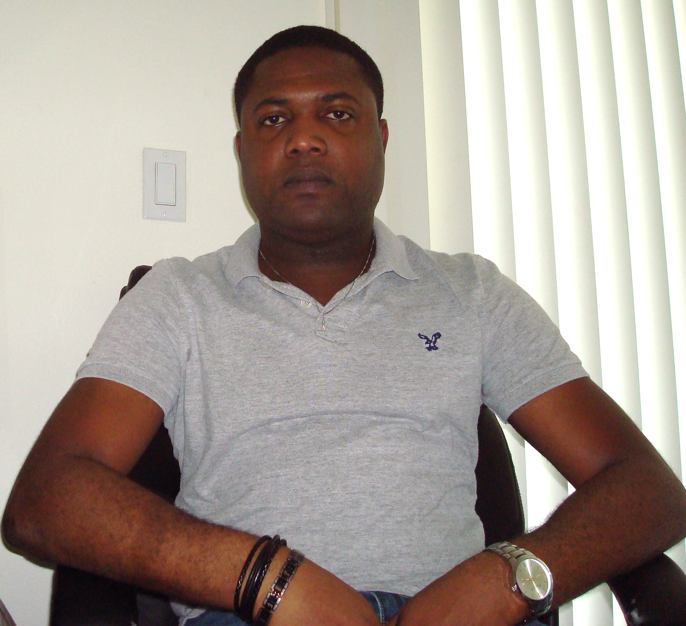 |  | 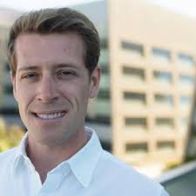
Kim Branson, PhD  Genentech  Early Clinical Development  Head of A.I. | Eric Martin, PhD  Novartis  Computational Chemistry  Director |  | Gavin Jones, PhD  IBM Research - Almaden  Quantum Applications  Research staff | Michael Keiser, PhD  Assistant Professor  UCSF

The event is FREE and open to the community. More information at: calacs.org or email aliciaataylor@gmail.com

